GENERAL description

***karaloop* P2**

***karaloop* – Prototype 2 (P2)**

**P2** is a light headset that measures voluntary movements of the face and translates them into mouse or keyboard commands sent via Bluetooth Low Energy (BLE) to wirelessly communicate with any PC, iOS or Android device. Unlike **P1**, **P2** integrates headset and control box in a single unit.

**P2** incorporates a headset band (1) that houses a rechargeable built-in battery and an Arduino-compatible Bluefruit nRF52 Feather board which is automatically recognized via BLE as a human-interface device (HID) by any PC, iOS or Android device. The headset further integrates three mechanical contact probes (2, 3, 4) that detect voluntary movements of the face; a switch-based probe (2) that captures forehead movements, and two potentiometric probes (3, 4) that capture orofacial movements bilaterally. Several headset probe holders (5) allow the adjustment of the mechanical contact probes (2, 3, 4) to fit different face contours. **P2**’s modular design further facilitates the easy replacement of probes and the rapid testing of new probe designs.

3

2

4

1

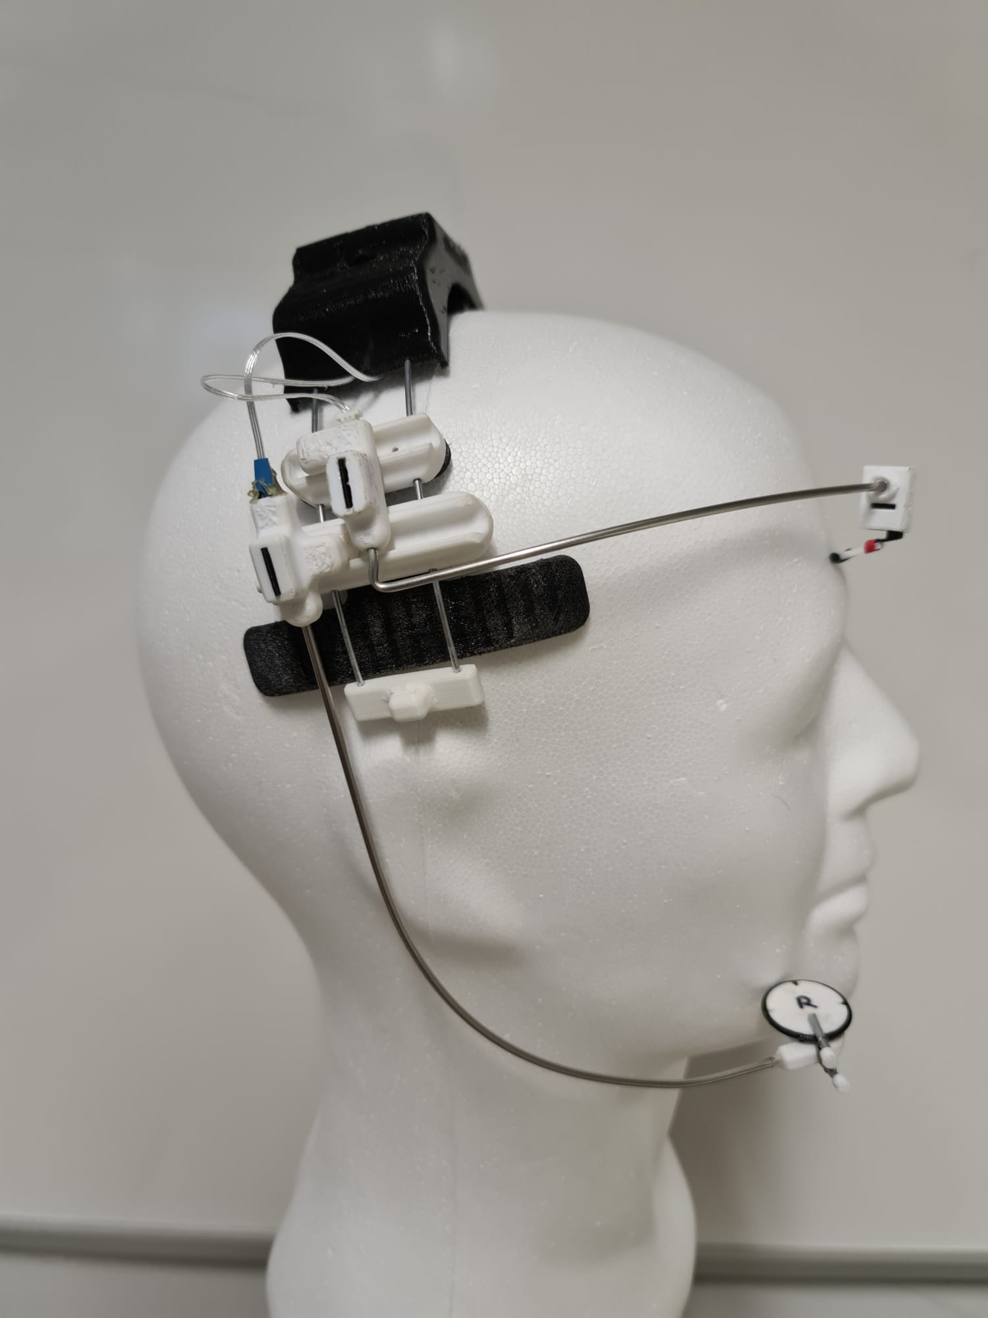

5

**P2 components. (1)** Headset band; **(2)** Switch probe; **(3)** Left potentiometric probe; **(4)** Right potentiometric probe; **(5)** headset probe holders.

Assembly description

## ***karaloop* P2**

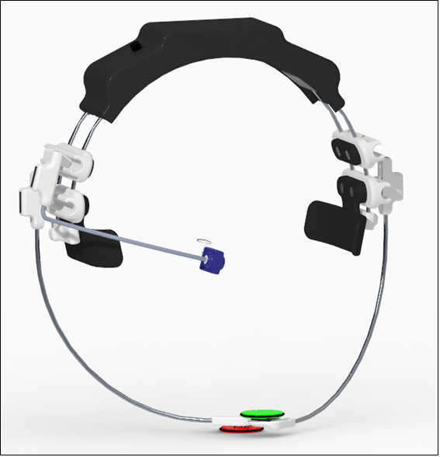

Contents

***karaloop*** *P2 – General description* 1

*Assembly description* 4

1. Headset band sub-assembly 7

Fabrication process 8

2. Switch probe sub-assembly 10

Fabrication process 11

3. Potentiometric probe sub-assembly 13

Fabrication process 14

Electronic parts list (EPL) 16

General circuit schematic 17

Mechanical parts list (MPL) 18

Printed parts list (PPL) 19

## General assembly

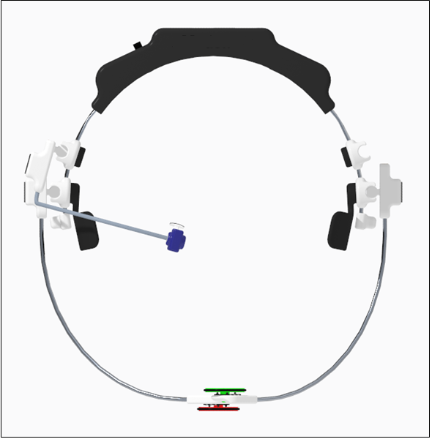

2

3

1

|  |  |  |  |
| --- | --- | --- | --- |
| N° | Part description | Abbreviation | Quantity |
| 1 | Headset band sub-assembly | HB | 1 |
| 2 | Switch probe sub-assembly | SP | 1 |
| 3 | Potentiometric probes sub-assembly | PP | 2 |

## Headset band sub-assembly

The padded headset band ensures stable yet adjustable potentiometric and switch probes functionality. 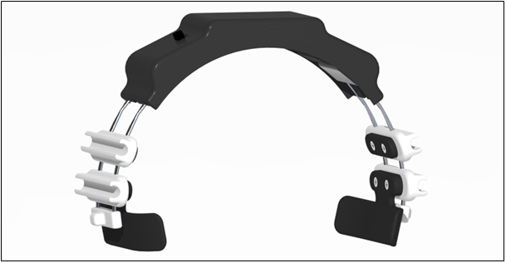

|  |  |  |  |  |  |  |  |  |  |  |  |  |  |  |  |  |  |  |  |  |  |  |  |  |  |  |  |  |  |  |  |  |  |  |  |  |  |  |  |  |  |  |  |  |  |  |  |  |  |  |  |  |  |  |  |  |  |  |  |  |  |  |  |  |  |  |  |  |  |  |  |  |  |  |  |  |  |  |  |  |  |  |  |  |  |  |
| --- | --- | --- | --- | --- | --- | --- | --- | --- | --- | --- | --- | --- | --- | --- | --- | --- | --- | --- | --- | --- | --- | --- | --- | --- | --- | --- | --- | --- | --- | --- | --- | --- | --- | --- | --- | --- | --- | --- | --- | --- | --- | --- | --- | --- | --- | --- | --- | --- | --- | --- | --- | --- | --- | --- | --- | --- | --- | --- | --- | --- | --- | --- | --- | --- | --- | --- | --- | --- | --- | --- | --- | --- | --- | --- | --- | --- | --- | --- | --- | --- | --- | --- | --- | --- | --- | --- |
| 1.17  1.16  1.15  1.1  1.13  1.10  1.14  1.7  1.6  1.3  1.4  1.5  1.12  1.2  1.8  1.9  1.11 | |  |  |  |  | | --- | --- | --- | --- | | N° | Part description | | | | 1.1 | | Slide Switch ON/OFF | | | | 1.2 | | Switch holder | | | | 1.3 | | WR-WTB 2 pos. conn. (2x) | | | | 1.4 | | WR-WTB 3 pos. conn. (2x) | | | | 1.5 | | Connections PCB hub holder | | | | 1.6 | | End part headband (2x) | | | | 1.7 | | Bottom flex. side pad (2x) | | | | 1.8 | | Top flex. side pad (2x) | | | | 1.9 | | Bluefruit holder | | | | 1.10 | | Probes holder (4x) | | | | 1.11 | | Curved wires (2x) | | | | 1.12 | | Battery holder | | | | 1.13 | | Connections PCB hub | | | | 1.14 | | Battery LiPo 3.7V | | | | 1.15 | | Bluefruit nRF52832 feather | | | | 1.16 | Flat head screws M2.5x6 (10x) | | | 1.17 | Flexible top cover | | |

### Fabrication process

MATERIALS NEEDED can be found in Electronical part list (EPL, page 15), Mechanical Part List (MPL, page 17) and Printed Parts List (PPL, page 18).

|  |  |  |
| --- | --- | --- |
| Step | Description | Materials needed |
| 1.1 | **Curved wires *(Part N°1.11)***  Bend two wires as illustrated with a bending radius of 80 mm and cut them to an angle of 140°. | * Wires of Ø1.6 mm *(MPL N°2)* * Pattern for each curved wire: |
| 1.2 | **Connections PCB Hub *(Parts N°1.3, 1.4, 1.13)***   1. Shorten (2x) the Connections PCB hub *(Part N°1.13)* to a length of 30 mm. 2. Solder (2x) the two connectors *(Parts N°1.3, 1.4)* to theConnections PCB hub *(Part N°1.13)* following the Connections PCB 3. hub pinout on the right. | * WR-WTB 2 pos. conn *(EPL N°8)* * WR-WTB 3 pos. conn *(EPL N°5)* * Connections PCB hub *(EPL N°4)* * Connections PCB hub pinout:   30 mm mm |
| 1.3 | **Headset band assembly *(Parts N°1.1, 1.2, 1.5, 1.6, 1.7, 1.8, 1.9, 1.10, 1.12, 1.15, 1.16 – Step N°1.1, 1.2)***   1. Slide the Bluefruit holder *(Part N°1.9)*, the switch holder *(Part N°1.2)* and the battery holder *(Part N°1.12)* through the two curved wires (*Part N°1.11;* Step N°1.1). 2. Slide the two PCB conn. holders *(Part N°1.5; 1x side),* the four probe holders *(Part N°1.10; 2x side)* and the two-end parts headband *(Part N°1.6; 1x side)* through the two curved wires*.* 3. Screw with flat head screws *(Part N°1.16)*:  * the connections PCB hubs *(Part N°1.13; Step N°1.2; 1x side)* tothe PCB conn. holders *(Part N°1.5; 1x side).* * the slide switch *(Part N°1.1) to* the switch holder *(Part N°1.2).* * the Bluefruit nRF52832 feather *(Part N°1.15)* tothe bluefruit holder *(Part N°1.9).* * the top flex. side pads *(Part N°1.8; 1x side)* tothe top probe holders *(Part N°1.10; 1x side).* * bottom flex. side pad *(Part N°1.7; 1x side)* tothe bottom probes holders *(Part N°1.10; 1x side).*  1. Attach the LiPo battery 3.7V *(Part N°1.14)* tothe battery holder *(Part N°1.12)* with double tape. | * Bluefruit holder *(PPL N°7)* * Switch holder *(PPL N°3)* * Battery holder *(PPL N°9)* * PCB conn. holder *(PPL N°4)* * Probe holder *(PPL N°8)* * Top flex. side pad *(PPL N°6)* * Bottom flex. side pad *(PPL N°5)* * End part headband *(PPL N°2)* * Bluefruit nRF52832 feather *(EPL N°1)* * Slide Switch ON/OFF *(EPL N°3)* * Battery LiPo 3.7V *(EPL N°2)* * Flat head screws M2.5x6 *(MPL N°1)* * Connections PCB hub *(EPL N°4)* * Double tape |

|  |  |  |
| --- | --- | --- |
| 1.4 | Electrical wiring *(Parts N°1.1, 1.13, 1.14, 1.15 – Step N°1.2)*  Connect the slide switch *(Part N°1.1),* the Connections PCB hubs *(Part N°1.13; Step N°1.2)*, and the battery *(Part N°1.14)* with the Bluefruit nRF52832 feather *(Part N°1.15)* following the *electrical schematic (Pag. 16).*  Use electrical wires within the range of 16 to 28 AWG. | * Bluefruit nRF52832 feather *(EPL N°1)* * Slide Switch ON/OFF *(EPL N°3)* * Battery LiPo 3.7V *(EPL N°2)* * Connections PCB hub *(EPL N°4)* * Electrical wires (from 16 to 28 AWG) |
| 1.5 | **Top cover assembly *(Parts N°1.17)***  Cover everything up attaching the flexible top cover *(Part N°1.17)* to the curved wires *(Part N°1.11).* | * Flexible top cover *(PPL N°1)* |

## 2. Switch probe sub-assembly

The switch probe *(Part N°2)* consists of a mechanical unit that detects voluntary forehead movements when a lever *(Part N°2.1)* in contact with the forehead changes the state of a snap action switch *(Part N°2.2)* upon rotation. The switch probe holder *(Part N°2.8)* slides through the headset band probe holder *(Part N°1.10)* and the switch housing *(**Part N°2.3)* rotates around the switch probe tube *(Part N°2.5)* to fit the contour of any face.

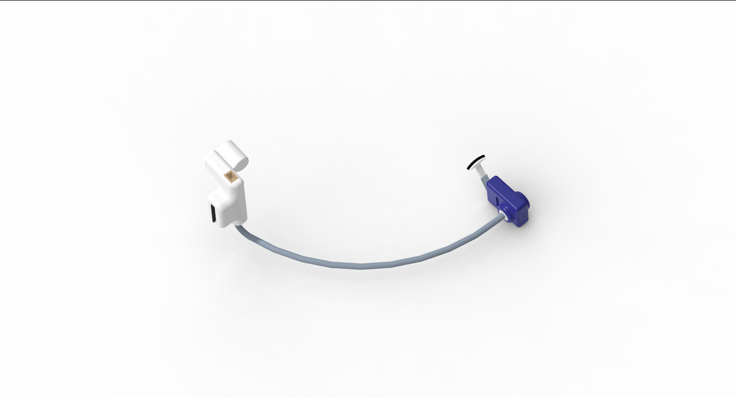

|  |  |  |  |  |  |  |  |  |  |  |  |  |  |  |  |  |  |  |  |  |  |
| --- | --- | --- | --- | --- | --- | --- | --- | --- | --- | --- | --- | --- | --- | --- | --- | --- | --- | --- | --- | --- | --- |
| 2.3  2.4  2.2  2.1  2.5  2.9  2.8  2.6  2.7 | |  |  | | --- | --- | | N° | Part description | | 2.1 | Switch lever arm | | 2.2 | Snap action switch | | 2.3 | Switch housing | | 2.4 | Switch housing axe | | 2.5 | Switch probe tube | | 2.6 | Flexible torsion spring | | 2.7 | WR-WTB 2 male. pos. conn | | 2.8 | Switch probe holder | | 2.9 | Rubber padding | |

### Fabrication process

MATERIALS NEEDED can be found in Electronical part list (EPL, page 15), Mechanical Part List (MPL, page 17) and Printed Parts List (PPL, page 18).

|  |  |  |
| --- | --- | --- |
| Step | Description | Materials needed |
| 2.1 | **Switch assembly *(Parts N°2.1, 2.2, 2.9)***   1. Cut an 8mm piece of Ø 20 mm rubber *(Part N°2.9)* for padding the lever arm *(Part N°2.1)*. 2. Glue the rubber padding *(Part N°2.9)* onto the switch lever arm *(Part N°2.1)* as indicated in the figure on the right. 3. Let the glue dry before continuing. 4. Glue the Switch lever arm *(Part N°2.1)* onto the metallic lever of the switch *(Part N°2.2)*. 5. Let the glue dry before continuing. 6. Further secure the switch lever arm *(Part N°2.1)* onto the metallic lever of the switch *(Part N°2.2)* with tape as illustrated in the figure on the right (in red). | * Rubber O-ring of Ø 20 mm *(**MPL N°4**)* * Snap action switch *(**EPL N°10**)* * Metal glue: CYANOACRYLATE INSTANT ADHESIVES such as Ergo®5011 or Ergo®5901. * Tape |
| 2.2 | **Metal conduit *(Parts N°2.4, 2.5)***   1. Cut a 170mm piece long of the Inox tube *(Part N°2.5)*. 2. Bend the tube in a plane as illustrated in the top figure on the right. 3. Bend the tube a second time in a plane perpendicular to the curved tube as illustrated in the mid/bottom figures on the right. 4. Insert the cut tube *(Part N°2.5)* into the switch housing tube *(Part N°2.4)* as indicated in the bottom figure on the right. 5. Secure the assembly applying metal glue at around the contours interfacing the tube *(Part N°2.5)* with the switch housing tube *(Part N°2.4)*. 6. Let the glue dry before continuing. | * Switch probe tube *(**MPL N°3**)* * Switch housing tube *(**PPL N°12**)* * Metal glue: CYANOACRYLATE INSTANT ADHESIVES such as Ergo®5011 or Ergo®5901 |
| 2.3 | **Switch housing assembly *(Parts N°2.3, 2.4, Step N°2.2)***   1. Route two 180mm long insulated wires through the metal conduit *(Step N°2)*. 2. Insert the switch housing tube *(Part N°2.4)* of the metal conduit *(Step N°2.2)* and the wires *(Step N°2.3.1)* into the switch housing (*Part N°2.3*). 3. Route in the wires through the window above the cylindrical opening of the switch housing *(Part N°2.3)* as indicated in the figure on the right. | * Insulated wire of 30 AWG *(**EPL N°12**)* * Switch housing *(**PPL N°11**)* |

|  |  |  |  |  |
| --- | --- | --- | --- | --- |
| 2.4 | Switch probe holder assembly *(Parts N°2.6, 2.7, 2.8)*   1. Route the wires coming out from the other end of the Metal conduit through the Flexible torsion spring *(Part N°2.6)*. 2. Insert the WR-WTB 2 male pos. connector *(Part N°2.7),* the Flexible torsion spring *(Part N°2.6)* and the switch housing assembly from Step N°2.3 into the switch probe holder part *(Part N°2.8).* 3. Solder the wires coming out from the metal conduit *(Part N°2.5) into the* WR-WTB 2 male pos. connector *(Part N°2.7)* following the *wiring schematic (P. 15).* | * Switch probe holder *(**PPL N°13**)* * Flexible torsion spring *(**PPL N°14**)* * WR-WTB male 2 pos. connector *(**EPL N°7**)*      |  |  | | --- | --- | |  |  | |
| 2.5 | **Electrical wiring *(Parts N°2.2, 2.3, 2.5, 2.7)***   1. Solder the two wires routed through the window of the switch housing *(Part N°2.3), from the Step N°2.3,* with the pins of the switch *(Part N°2.2)* following the *wiring schematic (P. 15).* 2. Insert the switch *(Part N°2.2)* into the switch housing *(Part N°2.3)*. 3. Solder the two wires coming out from the Headset band side of the Inox tube (Part N°2.5) with the with the WR-WTB 2 male 2 pos. connector *(Part N°2.7)* following the*wiring schematic (P. 15)**.* | * Snap action switch *(**EPL N°10**)* * WR-WTB male 2 pos. connector *(**EPL N°7**)* * Switch housing *(**PPL N°11**)* |
| 2.6 | **Switch probe cable**   1. Make a 3-contacts cable of 50 mm length from the 6-contacts flat cable. 2. Use a crimper tool to crimp female terminals in all contacts (3x crimped terminals in each end of the cable). 3. Insert the crimped contacts into a WR-WTB female 3 pos. connector (1x connector in each end of the cable). | * WR-WTB female 2 pos. connector *(EPL N°7)* * 6-contacts flat cable *(EPL N°13)* * Female crimp terminal*(EPL N°11)* * Crimper for 28 to 32 AWG wires (tools) |

## Potentiometric probe sub-assembly

Both potentiometric probes (Part N°3) consist of a mechanical unit that translates orofacial movements into a rotating wheel (mobile unit), and a potentiometer (Part N°3.6) sensing unit that measures the voltage corresponding to the wheel rotation. The probes slide through the headset band probe holders (Part N°1.10) to fit the contour of any face.

|  |  |
| --- | --- |
|  | 3.1  3.2  3.3  3.4 |

|  |  |  |  |  |  |  |  |  |  |  |  |  |  |  |  |  |  |  |  |
| --- | --- | --- | --- | --- | --- | --- | --- | --- | --- | --- | --- | --- | --- | --- | --- | --- | --- | --- | --- |
| 3.4  3.5  3.6  3.7  3.8 | |  |  | | --- | --- | | N° | Part description | | 3.1 | WR-WTB 3 pos. conn. | | 3.2 | Potentiometric probe holder | | 3.3 | Flexible torsion spring | | 3.4 | Potentiometric probe tube | | 3.5 | Potentiometer holder | | 3.6 | Flat shaftless potentiometer | | 3.7 | Potentiometric wheel | | 3.8 | Rubber O-ring | |

### Fabrication process

Both (left/right) potentiometric probes share the same process except step 3.5 which involve different (left/right) potentiometric probe holder *(Part N°3.2).*

MATERIALS NEEDED can be found in Electronical part list (EPL, page 15), Mechanical Part List (MPL, page 17) and Printed Parts List (PPL, page 18).

|  |  |  |
| --- | --- | --- |
| Step | Description | Materials needed |
| 3.1 | **Electrical wiring *(Part N°3.6)***  Cut 3x 200 mm length insulated wires of 30 AWG and connect them to each pin of the flat shaftless potentiometer *(Part N°3.6)* | * Insulated wire of 30 AWG *(EPL N°12)* * Flat shaftless potentiometer *(EPL N°9)* |
| 3.2 | **Potentiometer housing assembly *(Part N°3.5, 3.6, 3.7, 3.8)***   1. Insert the flat shaftless potentiometer *(Part N°3.6)* into the potentiometer holder *(Part N°3.5).* 2. Insert the shaft of the potentiometric wheel *(Part N°3.7)* into the flat shaftless potentiometer *(Part N°3.6).* 3. Cover thepotentiometric wheel *(Part N°3.7)* contourwith therubber O-ring *(Part N°3.8).* | * Flat shaftless potentiometer *(EPL N°9)*      * Potentiometric wheel *(PPL N°17)* * Potentiometer holder *(PPL N°16)* * Rubber O’ring *(MPL N°4)* |
| 3.3 | **Potentiometric probe tube *(Part N°3.4)***   1. Shape the potentiometric probe tube *(Part N°3.4, 2x)* as illustrated in the pattern on the right using an inox tube of Ø2x1.5 mm. 2. Deburr and polish the ends of the tube with a hand-held milling machine. | * Inox tube of Ø2x1.5 mm *(MPL N°3)* * Hand-held milling machine * Pattern for the potentiometric probe tube: |

|  |  |  |
| --- | --- | --- |
| 3.4 | Potentiometric probe assembly – Sensor side *(Part N°3.5 – Steps N°3.1, 3.3)*   1. Route the potentiometer wires (*Step N°3.1)* inside the potentiometric probes tube (*Step N°3.3*) from the sensor to the headset band side. 2. Apply metal glue on the sensor side of the potentiometric probe tube *(Step N°3.3)* and insert the tube into the potentiometer holder *(Part N°3.5).* 3. Let the glue dry for 2 hours before continuing. | * Metal glue: CYANOACRYLATE INSTANT ADHESIVES such as Ergo®5011 or Ergo®5901 |
| 3.5 | **Potentiometric probe assembly – Headset band side *(Parts N°3.1, 3.2, 3.3 – Step N°3.4)***   1. Route the wires coming out from the other end of the potentiometric probe tube *(Part N°3.4)* through the Flexible torsion spring *(Part N°3.3)*. 2. Insert *the* WR-WTB male connector *(Part N°3.1),* the flexible torsion spring *(Part N°3.3)* and the potentiometric probe assembly from *Step N°3.4* into the Potentiometric probe holder *(Part N°3.2).* 3. Solder the wires coming out from the potentiometric probe tube *(Part N°3.4)* into the WR-WTB 3 male pos. connector *(Part N°3.1)* following the *wiring schematic (P. 15).* | * Flexible torsion spring *(PPL N°14)* * WR-WTB male connector *(EPL N°5)* * Potentiometric probe holder *(PPL N°15)*      |  |  | | --- | --- | |  |  | |
| 3.6 | **Electrical wiring *(Part N°3.1, 3.4 – Step N°3.5)***  Connect the 3 wires coming out from the headset band side of the potentiometric probe tube *(Part N°3.4; Step N°3.5)* with the WR-WTB male connector *(Part N°3.1)* following the *electrical schematic (Pag. 16).* | * WR-WTB male 3 pos. connector *(EPL N°5)* |
| 3.7 | **Potentiometric probe cable**   1. Make a 3-contacts cable of 50 mm length from the 6-contacts flat cable. 2. Use a crimper tool to crimp female terminals in all contacts (3x crimped terminals in each end of the cable). 3. Insert the crimped contacts into a WR-WTB female 3 pos. connector (1x connector in each end of the cable). | * WR-WTB female 3 pos. connector *(EPL N°6)* * 6-contacts flat cable *(EPL N°13)* * Female crimp terminal*(EPL N°11)* * Crimper for 28 to 32 AWG wires (tools) |

## Electronic parts list (EPL)

|  |  |  |  |  |
| --- | --- | --- | --- | --- |
| N° | Part description | Quantity | Datasheet | Supplier Link |
| 1 | Bluefruit nRF52 feather | 1 | [CP-EX3051WN Datasheet - Hitachi Digital Media Group](https://github.com/xmotion-project/karaloop/blob/main/karaloop_P2_0/Technical%20Documentation/Datasheets/Bluefruit%20nRF52%20feather.pdf) | [Nrf52](https://www.adafruit.com/product/3574) |
| 2 | Rechargeable battery Li-Po 3.7V 350mAh | 1 | [CP-EX3051WN Datasheet - Hitachi Digital Media Group](https://github.com/xmotion-project/karaloop/blob/main/karaloop_P2_0/Technical%20Documentation/Datasheets/Rechargeable%20battery%20Li-Po%203.7V%20350mAh.pdf) | [ICP602823PA](https://www.distrelec.ch/fr/batterie-accumulateurs-rechargeable-li-po-7v-350mah-renata-icp602823pa-01/p/30158722?q=batterie+lipo&pos=18&origPos=18&origPageSize=50&track=true) |
| 3 | Slide Switch ON/OFF | 1 | [CP-EX3051WN Datasheet - Hitachi Digital Media Group](https://github.com/xmotion-project/karaloop/blob/main/karaloop_P2_0/Technical%20Documentation/Datasheets/Slide%20Switch%20ONOFF.pdf) | [RND 210-00581](https://www.distrelec.ch/en/miniature-slide-switch-1co-on-on-soldering-lugs-rnd-components-rnd-210-00581/p/30152605?origPos=61&q=&pos=61&no-cache=true&origPageSize=50&track=true&marketingPopup=false) |
| 4 | Connections PCB hub | 2 | [CP-EX3051WN Datasheet - Hitachi Digital Media Group](https://cdn-shop.adafruit.com/datasheets/1325top.gif) | [Adafruit FPC Stick](https://www.adafruit.com/product/1325) |
| 5 | WR-WTB male 3 pos. connector | 2 | [CP-EX3051WN Datasheet - Hitachi Digital Media Group](https://github.com/xmotion-project/karaloop/blob/main/karaloop_P2_0/Technical%20Documentation/Datasheets/WR-WTB%20male%203%20pos.%20connector.pdf) | [665303124022](https://www.mouser.fr/ProductDetail/Wurth-Elektronik/665303124022?qs=a9WhcLg8qCyV5ri9HU4hCQ%3D%3D) |
| 6 | WR-WTB female 3 pos. connector | 2 | [CP-EX3051WN Datasheet - Hitachi Digital Media Group](https://github.com/xmotion-project/karaloop/blob/main/karaloop_P2_0/Technical%20Documentation/Datasheets/WR-WTB%20female%203%20pos.%20connector.pdf) | [665003113322](https://www.mouser.fr/ProductDetail/?qs=a9WhcLg8qCx0Aj2fgOQ3BQ%3D%3D) |
| 7 | WR-WTB female 2 pos. connector | 2 | [CP-EX3051WN Datasheet - Hitachi Digital Media Group](https://github.com/xmotion-project/karaloop/blob/main/karaloop_P2_0/Technical%20Documentation/Datasheets/WR-WTB%20female%202%20pos.%20connector.pdf) | [665002113322](https://www.mouser.fr/ProductDetail/?qs=a9WhcLg8qCy4BTanb8zFpg%3D%3D) |
| 8 | WR-WTB male 2 pos. connector | 2 | [CP-EX3051WN Datasheet - Hitachi Digital Media Group](https://github.com/xmotion-project/karaloop/blob/main/karaloop_P2_0/Technical%20Documentation/Datasheets/WR-WTB%20male%202%20pos.%20connector.pdf) | [665302124022](https://www.mouser.fr/ProductDetail/Wurth-Elektronik/665302124022?qs=a9WhcLg8qCx0IT99cXBqTA==) |
| 9 | Flat shaftless potentiometer | 2 | [CP-EX3051WN Datasheet - Hitachi Digital Media Group](https://github.com/xmotion-project/karaloop/blob/main/karaloop_P2_0/Technical%20Documentation/Datasheets/Flat%20shaftless%20potentiometer.pdf) | [RDC503052A](https://www.mouser.fr/ProductDetail/Alps-Alpine/RDC503052A?qs=j%252B1pi9TdxUaVD4zRKg%252Bh9Q%3D%3D) |
| 10 | Snap action switches | 2 | [CP-EX3051WN Datasheet - Hitachi Digital Media Group](https://github.com/xmotion-project/karaloop/blob/main/karaloop_P2_0/Technical%20Documentation/Datasheets/Snap%20action%20switches.pdf) | [D2MQ-4L-105-1](https://www.mouser.fr/ProductDetail/Omron-Electronics/D2MQ-4L-105-1?qs=%2Fha2pyFaduirfVncLqSzK9%252BaMI8ihWlE9JsW4Bp5SzDhWDglI3A1vQ%3D%3D) |
| 11 | Female crimp terminal | 50 | [CP-EX3051WN Datasheet - Hitachi Digital Media Group](https://github.com/xmotion-project/karaloop/blob/main/karaloop_P2_0/Technical%20Documentation/Datasheets/Female%20crimp%20terminal.pdf) | [66510113722](https://www.mouser.fr/ProductDetail/?qs=a9WhcLg8qCzz4scZZBnxZw%3D%3D) |
| 12 | Insulated wire of 30 AWG | 2 m | [CP-EX3051WN Datasheet - Hitachi Digital Media Group](https://github.com/xmotion-project/karaloop/blob/main/karaloop_P2_0/Technical%20Documentation/Datasheets/Insulated%20wire%20of%2030%20AWG.pdf) | [5851 BK005](https://www.alphawire.com/en/OnlineTools/~/media/Files/MasterCatalog2011/HookUpWire.pdf) |
| 13 | 6-contacts flat cable | 30 mm | [CP-EX3051WN Datasheet - Hitachi Digital Media Group](https://github.com/xmotion-project/karaloop/blob/main/karaloop_P2_0/Technical%20Documentation/Datasheets/6-contacts%20flat%20cable.pdf) | [HF625/06-30](https://www.mouser.fr/ProductDetail/3M-Electronic-Solutions-Division/HF625-06-30?qs=uIeALhfqz5HFC4P%2FX%252BqQGQ==) |

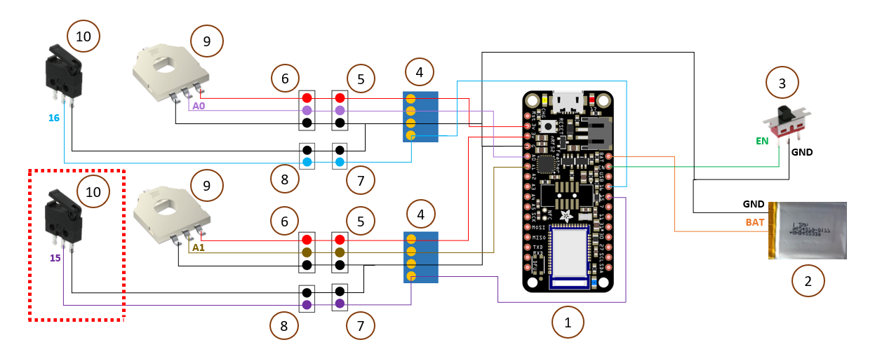

* **Remark** : The red dotted rectangle illustrates a second switch which could be added to capture voluntary forehead movements from the other side of the face.

## General circuit schematic

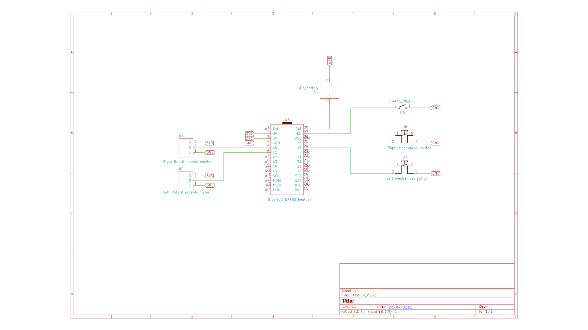

## Mechanical parts list (MPL)

ASSEMBLY: Headset band (HB), Switch probe (SP), Potentiometric probe (PP)

|  |  |  |  |  |
| --- | --- | --- | --- | --- |
| N° | Part description | Assembly | Quantity | Link |
| 1 | Flat head screw M2.5x6 | HB | 10 | [[M2.5x6]](https://www.bossard.com/eshop/fr-fr/vis-s-a-entrainement-interieur/vis-a-tete-cylindrique-a-six-pans-creux-entierement-filetees/p/3/?category=01.100.100.10&index=1&q=%3Arelevance%3A19D20820-0A5D-4344-AF13-2431AAD21588%3ACylindrique%3A74EC6A2E-3795-43DB-A517-12F3521785C5%3ASix%2Bpans%2Bcreux%3A709F6DBD-590D-4354-A89E-D804F869B1C8%3Aenti%25C3%25A8rement%2Bfilet%25C3%25A9e%3AA87579DF-7F9C-4535-9A8D-87830D3D5D84%3AAcier&variants-query=%3Arelevance%3A19D20820-0A5D-4344-AF13-2431AAD21588%3ACylindrique%3A74EC6A2E-3795-43DB-A517-12F3521785C5%3ASix%2Bpans%2Bcreux%3A709F6DBD-590D-4354-A89E-D804F869B1C8%3Aenti%25C3%25A8rement%2Bfilet%25C3%25A9e%3AA87579DF-7F9C-4535-9A8D-87830D3D5D84%3AAcier%3AF527C156-7E58-11D4-97D3-0000E8601B71%3AM3%3AF527C1B7-7E58-11D4-97D3-0000E8601B71%3A10) |
| 2 | Wire of Ø1.6 mm | HB | 1 (m) | [[Wire]](https://www.durovis.ch/index.php/fr/shop-ressorts-normalises/fil-ressort-standard-disponible.html) |
| 3 | Inox tube of Ø2x1.5 mm | SP, PP | 1 (m) | [[Tube]](https://www.interalloy.ch/fr/produkte/lagerliste.php) |
| 4 | Rubber O-ring of Ø 20 mm | SP, PP | 3 | [[Oring]](https://www.conrad.fr/p/basetech-bt-1697192-50-pcs-assortiment-de-joints-toriques-5-20-mm-contenu-1-pcs-1697192) |

## Printed parts list (PPL)

ASSEMBLY: Headset band (HB), Switch probe (SP), Potentiometric probe (PP)

|  |  |  |  |  |  |
| --- | --- | --- | --- | --- | --- |
| N° | Part description | Assembly | Quantity | Part name | Printing material |
| 1 | Flexible top cover | HB | 1 | [flexible_top_cover.stl](https://github.com/xmotion-project/karaloop/blob/main/karaloop_P2_0/Hardware/Mechanical%20Design/Sub-assembly/Headset%20band/STL/flexible_top_cover.stl) | TPU |
| 2 | End part headband | HB | 2 | [end_part_headband.stl](https://github.com/xmotion-project/karaloop/blob/main/karaloop_P2_0/Hardware/Mechanical%20Design/Sub-assembly/Headset%20band/STL/end_part_headband.stl) | Tough PLA or ABS |
| 3 | Switch holder | HB | 1 | [switch_holder.stl](https://github.com/xmotion-project/karaloop/blob/main/karaloop_P2_0/Hardware/Mechanical%20Design/Sub-assembly/Headset%20band/STL/switch_holder.stl) | TPU |
| 4 | PCB conn. holder | HB | 2 | [PCB_conn_holder.stl](https://github.com/xmotion-project/karaloop/blob/main/karaloop_P2_0/Hardware/Mechanical%20Design/Sub-assembly/Headset%20band/STL/pcb_conn_holder.stl) | TPU |
| 5 | Bottom flex. side pad | HB | 2 | [bottom_flex_side_pad.stl](https://github.com/xmotion-project/karaloop/blob/main/karaloop_P2_0/Hardware/Mechanical%20Design/Sub-assembly/Headset%20band/STL/bottom_flex_side_pad.stl) | TPU |
| 6 | Top flex. side pad | HB | 2 | [top_flex_side_pad.stl](https://github.com/xmotion-project/karaloop/blob/main/karaloop_P2_0/Hardware/Mechanical%20Design/Sub-assembly/Headset%20band/STL/top_flex_side_pad.stl) | TPU |
| 7 | Bluefruit holder | HB | 1 | [bluefruit_holder.stl](https://github.com/xmotion-project/karaloop/blob/main/karaloop_P2_0/Hardware/Mechanical%20Design/Sub-assembly/Headset%20band/STL/bluefruit_holder.stl) | TPU |
| 8 | Probes’ holder | HB | 3 | [probe_holder.stl](https://github.com/xmotion-project/karaloop/blob/main/karaloop_P2_0/Hardware/Mechanical%20Design/Sub-assembly/Headset%20band/STL/proble_holder.stl) | Tough PLA or ABS |
| 9 | Battery holder | HB | 1 | [battery_holder.stl](https://github.com/xmotion-project/karaloop/blob/main/karaloop_P2_0/Hardware/Mechanical%20Design/Sub-assembly/Headset%20band/STL/battery_holder.stl) | TPU |
| 10 | Switch lever arm | SP | 1 | [switch_lever_arm.stl](https://github.com/xmotion-project/karaloop/blob/main/karaloop_P2_0/Hardware/Mechanical%20Design/Sub-assembly/Switch%20probe/STL/switch_lever_arm.stl) | Tough PLA or ABS |
| 11 | Switch housing | SP | 1 | [switch_housing.stl](https://github.com/xmotion-project/karaloop/blob/main/karaloop_P2_0/Hardware/Mechanical%20Design/Sub-assembly/Switch%20probe/STL/switch_housing.stl) | Tough PLA or ABS |
| 12 | Switch housing axe | SP | 1 | [switch_housing_axe.stl](https://github.com/xmotion-project/karaloop/blob/main/karaloop_P2_0/Hardware/Mechanical%20Design/Sub-assembly/Switch%20probe/STL/switch_housing_axe.stl) | Tough PLA or ABS |
| 13 | Switch probe holder | SP | 1 | [switch_probe_holder.stl](https://github.com/xmotion-project/karaloop/blob/main/karaloop_P2_0/Hardware/Mechanical%20Design/Sub-assembly/Switch%20probe/STL/switch_probe_holder.stl) | Tough PLA or ABS |
| 14 | Flexible torsion spring | SP, PP | 3 | [flexible_torsion_spring.stl](https://github.com/xmotion-project/karaloop/blob/main/karaloop_P2_0/Hardware/Mechanical%20Design/Sub-assembly/Switch%20probe/STL/flexible_torsion_spring.stl) | TPU |
| 15 | Potentiometric probe's holder right | PP | 1 | [potentiometric_probe_holder_r.stl](https://github.com/xmotion-project/karaloop/blob/main/karaloop_P2_0/Hardware/Mechanical%20Design/Sub-assembly/Potentiometric%20probes/STL/potentiometric_probe_holder_r.stl) | Tough PLA or ABS |
| 16 | Potentiometric probe's holder left | PP | 1 | [potentiometric_probe_holder_l.stl](https://github.com/xmotion-project/karaloop/blob/main/karaloop_P2_0/Hardware/Mechanical%20Design/Sub-assembly/Potentiometric%20probes/STL/potentiometric_probe_holder_l.stl) | Tough PLA or ABS |
| 17 | Potentiometer holder | PP | 2 | [potentiometer_holder.stl](https://github.com/xmotion-project/karaloop/blob/main/karaloop_P2_0/Hardware/Mechanical%20Design/Sub-assembly/Potentiometric%20probes/STL/potentiometer_holder.stl) | Tough PLA or ABS |
| 18 | Potentiometric wheel | PP | 2 | [potentiometric_wheel.stl](https://github.com/xmotion-project/karaloop/blob/main/karaloop_P2_0/Hardware/Mechanical%20Design/Sub-assembly/Potentiometric%20probes/STL/potentiometer_wheel.stl) | Tough PLA or ABS |